

**115 Strange Street**

**Kitchener**

**519-743-3702**

[**warrengreenhouses@hotmail.com**](mailto:warrengreenhouses@hotmail.com)

**Spring 2025**

With spring just around the corner, pansy fund-raising is a great way to raise money for your organization.

Pansies are an early season flowering favourite. Tolerant to cooler weather, they can be enjoyed outside beginning in April.

We will deliver your order to the location and date of your choice. You may choose your delivery date anytime between April 5th and 19th.

There is a 100 pot minimum to qualify for free delivery within a 60 km radius. If you are beyond the radius, contact us for a delivery fee estimate.

Send in your sign-up sheet early to secure your delivery date and please have all completed orders to us no later than **March 22nd**.

Pansy Pots are available in MIXED colours in the following sizes.

8” Round Decorative Bowl

12” Round Decorative Bowl

11” Hanging Basket

***COST***  ***Recommended Selling***

8” Pot $9.00 +HST $14.00- $16.00

12” Pot $12.00 +HST $20.00- $22.00

11” Baskets $14.00 +HST $22.00- $24.00

We strive for excellent quality and service. If you encounter any problems, please notify us immediately and we will do our best to rectify the situation.

Any credit inquiries must be made within 48 hours of delivery.

***Thank you and good luck!***

***Sheila***

**Pansies can be placed in sun to part sun areas and prefer to be kept moderately moist. They can withstand cold temperatures, but heavy frost or snow will damage open blooms. Best to place them undercover when frost is predicted.**

**Pinch spent blooms at the bottom of the stem to encourage new growth and blooming into summer months.**

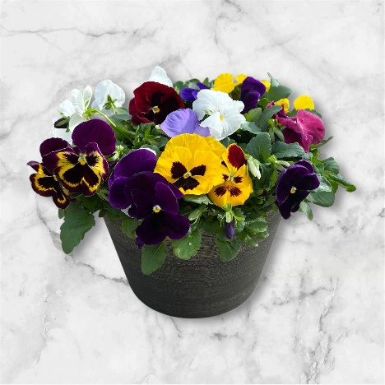

12” Round Pansy Pots



8” Round Pansy Pots

11” Cool Wave Pansy Baskets

.

**Pansy Fundraising Sign-Up Sheet**

GROUP NAME____________________________________________

CONTACT NAME_________________________________________

DELIVERY DATE_________________________________________

DELIVERY ADDRESS_____________________________________

CITY__________________________ POSTAL__________________

BILLING ADDRESS _______________________________________

CITY__________________________ POSTAL__________________

PHONE NUMBER ___________________________

___________________________

EMAIL _____________________________________

I ________________________________, will be the contact person for the above-named organization and therefore will be responsible for making payment within 30 days of my delivery. 2% interest will be added to overdue invoices. We accept cheque, cash or e-transfer.

SIGNATURE_______________________________

DATE_____________________________________